

(ISO 9001:2015 Certified), Accredited with ‘A’ Grade by NAAC

: 08258 - 281039 – 281263, Fax: 08258 – 281265

### Department of Computer Science and Engineering

B.E. CSE Program Accredited by NBA, New Delhi from 1-7-2018 to 30-6-2021

Report on Mini Project

**Quotes Website**

#### Course Code : 18CSE41 Course Name : Web Programming

##### Semester: V SEM Section: B

**Submitted To:**

## Mr. Krishna Prasad N Rao Assistant Professor

## Department of Computer Science and Engineering

**Submitted By:**

Nidhi Rai [4NM18CS103]

Iral Lavina Saldanha [4NM18CS066]

**Date of submission:**

08-12-2020

#### Signature of Course Instructor

# ABSTRACT

An application that enables the user to view the quotes and you can also be able to see already existing and their author . To quote is to transcribe what someone said or wrote, crediting that person .As a verb, to quote means to repeat someone's words, attributing them to their originator.

Good website practice and optimizing for conversion usually makes for good search engine optimization. These work together to ensure you drive quality traffic and can persuade that traffic to help you meet your business goals.

Factors to keep in mind while taking website design quotes Website design quote ideally must be simple, easy to understand and straightforward in nature. This is not always the case as many people do not give the quote to the clients in this manner. When giving the website cloning quote, it is those parts which are not said often takes the most important portion of the quote. Often many companies give the details in such small prints, that the client is bound to miss them.

# TABLE OF CONTENTS

Title Page i

Abstract ii

Table of Contents iii

Introduction 4

Problem Statement 5

Objectives 6

Literature Review 7

Methodology 8

Implementation Details 9

Results 10-13

Conclusion and Future Scope 14

References 15

# INTRODUCTION

Quotes are the words of wisdom and knowledge. These are actually the knowledge from one’s lifetime within a few words. And it’s a proven fact that people love quotes because – They can change your state of mind in a minute ,they help you make believe something, they are the easiest way to find inspiration and motivation around you, they are easy to memorize and pass along ,they are the advice from someone who has already lived and solved the same problem you are living.

# The famous quotes about life and success are said by the

greatest achievers in the history. They are valuable knowledge, wisdom and insights passed down to us from the past all the way to the present. Through these quotations, we are learning from their greatest experiences and wisdom. We personally use such motivational quotes throughout our life. We always surround ourself with these quotes. We post them in such places so that we can be inspired every day.

# PROBLEM STATEMENT

* To create a website that compiles quotes from figures in history ,

literature , science , entertainment and more .

* A good quote website can be an excellent resource for bloggers,

Influencers and social media marketers .

# OBJECTIVES

* The purpose of a website is to turn visitors into prospects. And the way to do this is to identify the major user types visiting your site, speak to their needs and give them a clear action step to take next.
* Inspires positive action is vital, we aren't interested in quotes with a negative tone.
* The main objective is to provide good collection for Inspirational , Life and Travel quotes .

* Even reading one or two of these every day will be a great source of positive energy for your day to day life.
* Our purpose with this bank of quotes is to have brief quotes that take less than 10 seconds to read and are inspiring/motivating not distracting.

# LITERATURE REVIEW

* Brainy Quote:

[https://www.brainyquote.com/](https://meet.google.com/linkredirect?authuser=0&dest=https%3A%2F%2Fwww.brainyquote.com%2F)

Brainy Quote provides an all-access pass to the world of quotations. Their quotations database is the largest on the web, and getting bigger every day. Whether it's a great quote for a birthday card, love letter, research paper or just for fun, Brainy Quote makes it easy to find great quotes.

* Wise Sayings and quotes:

[https://www.wisesayings.com/website-quotes/](https://meet.google.com/linkredirect?authuser=0&dest=https%3A%2F%2Fwww.wisesayings.com%2Fwebsite-quotes%2F)

Wise Sayings is a database of thousands of inspirational, humorous and thoughtful quotes, sorted by category for our enjoyment.

# 

# METHODOLOGY

# Hypertext Markup Language - The standard markup language for documents designed to be displayed in a web browser. It can be assisted by technologies such as Cascading Style Sheets (CSS) and scripting languages such as JavaScript.

# CSS Media Queries - A popular technique to deliver a tailored style sheet to desktops, laptops, tablets, and mobile phones by defining different style rules for different media types.

# Bootstrap - A front-end component library to build responsive, mobile-first websites. Bootstrap supports all major browsers except Internet Explorer 9.

# FontAwesome Icons - A font and icon toolkit based on CSS and Less. Font Awesome provides scalable vector icons that can be easily customizable in size, color, drop shadow, and anything that can be done using CSS.

# PHP - A server scripting language, and a powerful tool for making dynamic and interactive Web pages. PHP is a widely-used, free, and efficient alternative to competitors such as Microsoft's ASP.

# IMPLEMENTATION

* There are 5 modules in Quote Website :
* Home Page – It introduces the website /page to the user and entices them to visit more of the website.
* About – It gives us general meaning of the topic ‘Quote’ .
* Types – Inspirational , Life and Travel.
* Gallery – Galleries are a popular way of integrating images into website , allowing users to see several images clearly at once .
* Contact Us - A well-crafted contact page will enhance user experience and cultivate a strong relationship with your clients.
* Sign Up - Sign up is an action to register yourself for a new for a portal, application or newsletter .

**RESULTS AND DISCUSSIONS**

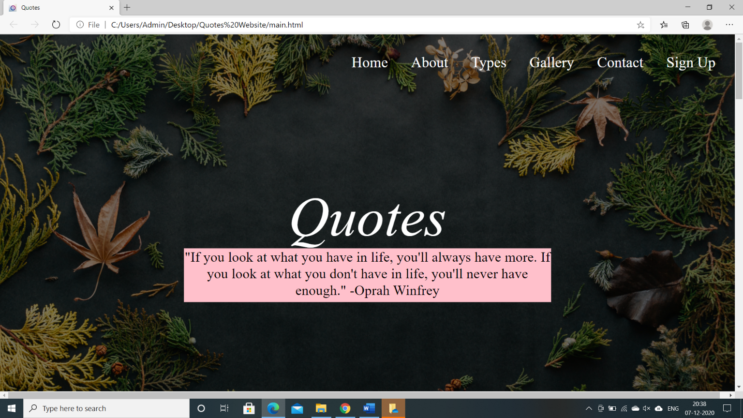

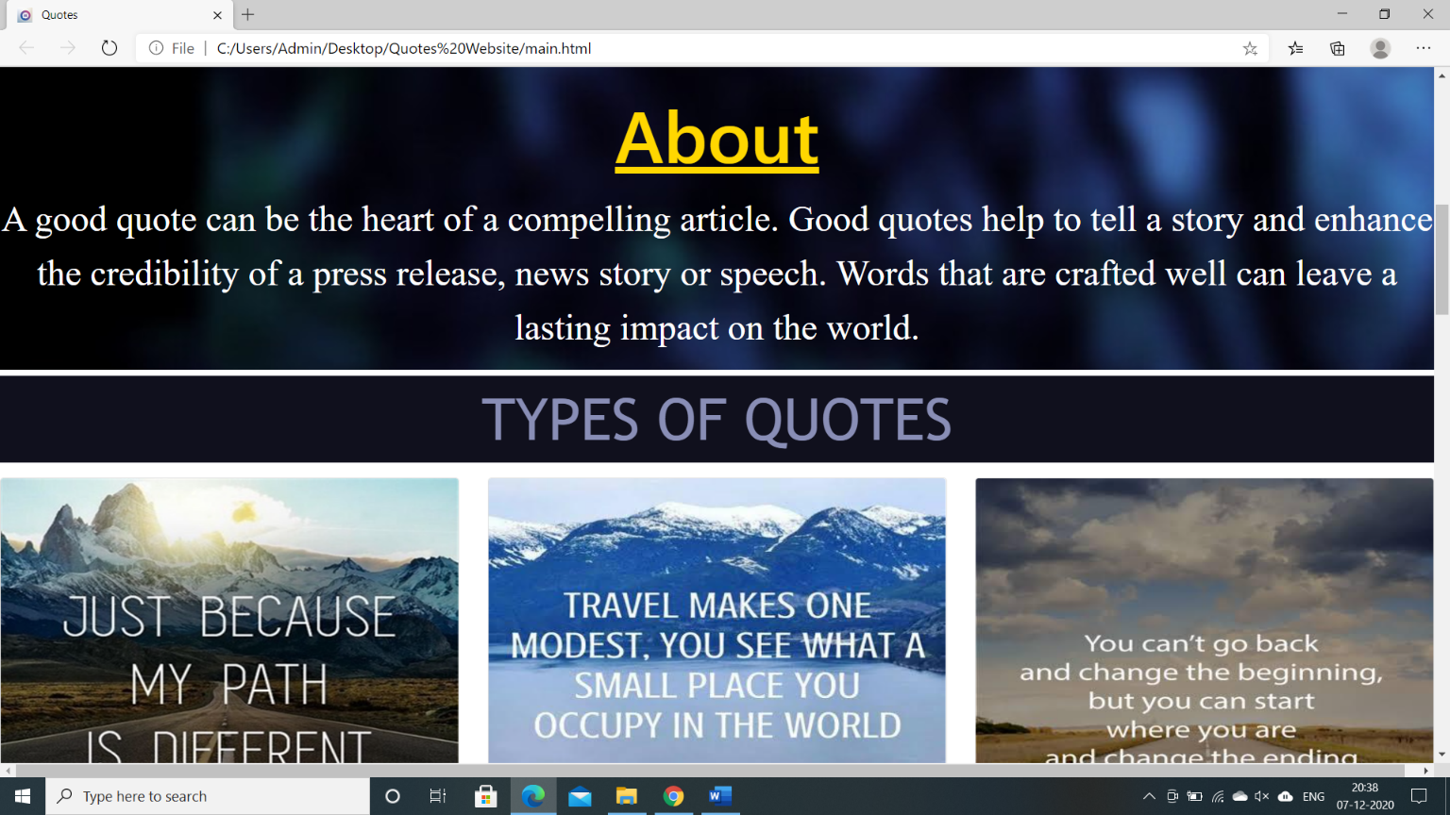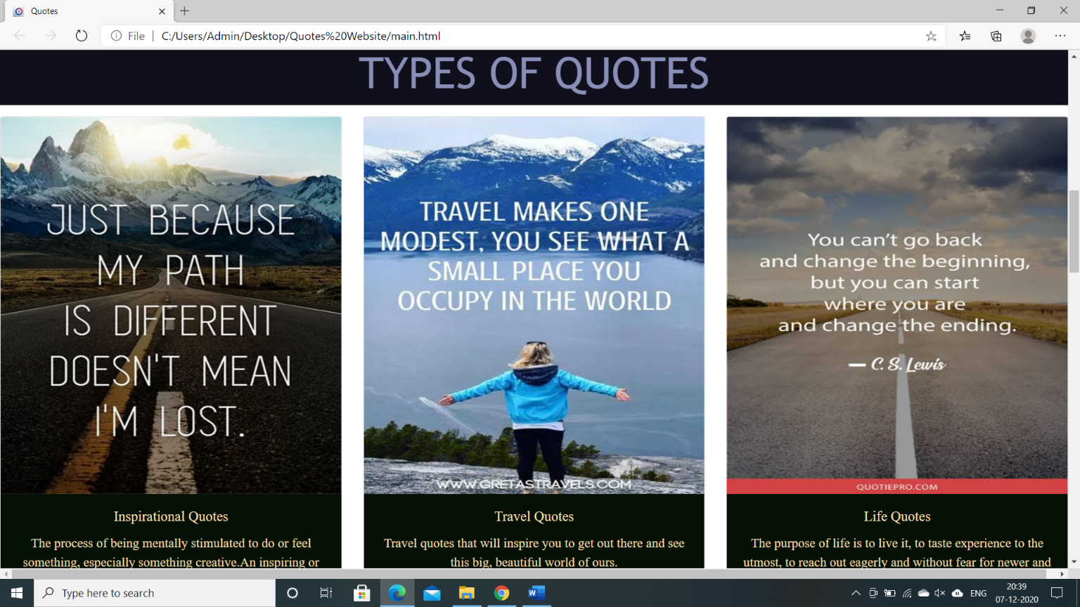

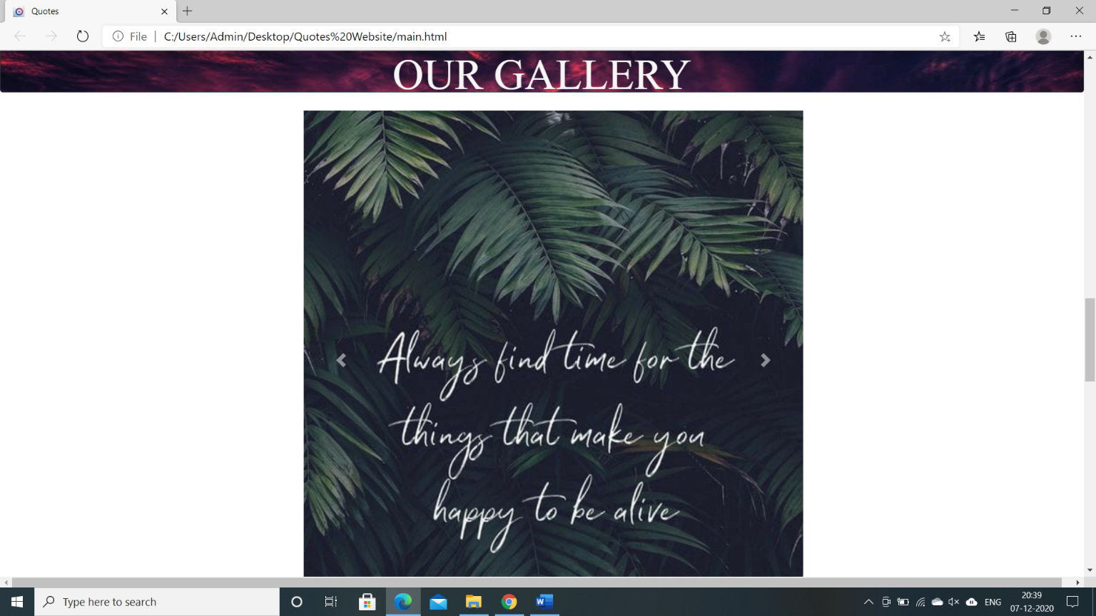

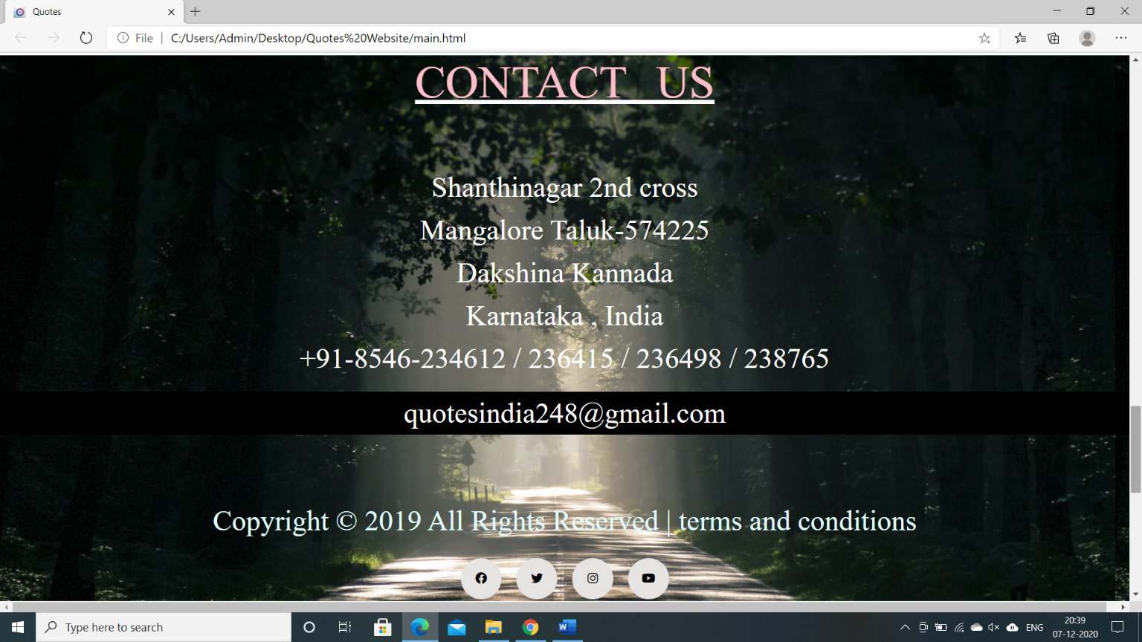

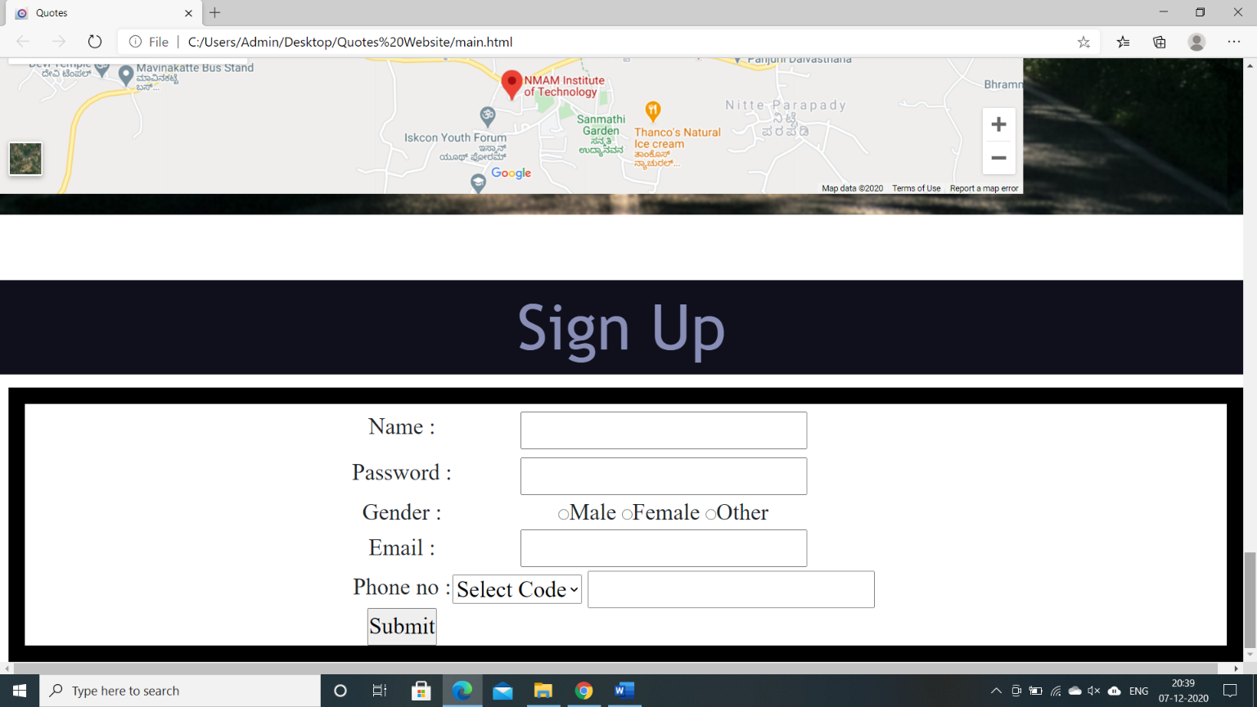

# CONCLUSION AND FUTURE SCOPE

Hence as a result they do not read them when they sign the agreement with the company. this leads to complications in future. There are some factors which you must therefore check before you finalize on the quote of the website. That will help you in the long run. What is included in the design have to be checked by the client first. The designer will initially send a mock image of the website that he proposes to make for you.

We trust you will find them insightful and useful. We hope it helps to motivates and inspires you to reach a new level of success and personal greatness in your life. Just as much as it does for us. Use these quotes to fill your life with positive, inspirational words that will fuel the engine of your mind. We certainly hope that you will also see this as a resource rather than just a quick article to read.

# REFERENCES

1. HD Wallpapers - [https://www.pexels.com/search/HD%20wallpaper/](https://meet.google.com/linkredirect?authuser=0&dest=https%3A%2F%2Fwww.pexels.com%2Fsearch%2FHD%2520wallpaper%2F)

[2] Inspirational Quotes - [https://www.pinterest.com/hibluchic/inspirational-quotes/](https://meet.google.com/linkredirect?authuser=0&dest=https%3A%2F%2Fwww.pinterest.com%2Fhibluchic%2Finspirational-quotes%2F)

[3] Life Quotes – [https://parade.com/937586/parade/life-quotes/](https://meet.google.com/linkredirect?authuser=0&dest=https%3A%2F%2Fparade.com%2F937586%2Fparade%2Flife-quotes%2F)

[4] Travel Quotes - [https://www.earthtrekkers.com/best-travel-quotes-images/](https://meet.google.com/linkredirect?authuser=0&dest=https%3A%2F%2Fwww.earthtrekkers.com%2Fbest-travel-quotes-images%2F)

[5] Information - [https://www.merriam-webster.com/dictionary/quote](https://meet.google.com/linkredirect?authuser=0&dest=https%3A%2F%2Fwww.merriam-webster.com%2Fdictionary%2Fquote)